Software Requirements Specification
for
Antarctica Glimpse Network
_____________________________
Prepared by Natch Sadindum - 1269188
Table of Contents
Table of Contents ii
Revision History ii
1. Introduction 1
1.1 Purpose 1
1.2 Document Conventions 1
1.3 Intended Audience and Reading Suggestions 1
1.4 Product Scope 1
1.5 References 1
2. Overall Description 2
2.1 Product Perspective 2
2.2 Product Functions 2
2.3 User Classes and Characteristics 4
2.4 Operating Environment 4
2.5 Design and Implementation Constraints 5
2.6 Assumptions and Dependencies 5
3. System Features 6
3.1 Login/Registration System 6
3.2 General User Interface 6
3.3 Change Password 8
3.4 Camera Feed 9
3.5 Camera Movement Control 9
3.6 Account Upgrade 10
3.7 Administrative Privileges 11
4. Other Nonfunctional Requirements 12
4.1 Performance Requirements 12
4.2 Safety Requirements 12
4.3 Security Requirements 12
5. Conclusion 12
5.1 Problems Analysis Graph 13

Revision History
Name | Date | Reason For Changes | Version
Natch Sadindum | 17/3/2020 | Initial Version | 1.0
Natch Sadindum | 20/3/2020 | Final Checks before handing in | 1.01

Introduction

Purpose
This document will describe the functional and non-functional software requirements of the Antarctica Glimpse Network.

Document Convention
No conventions are used in this document.

Intended Audience and Reading Suggestions
This document is intended to be read by the software engineers, product manager and project staff directly involved in the development process of the Antarctica Glimpse Network, as well as the client and testers.

Product Scope
This project is intended to provide a means for NZASA portal administrators to manage rovers and their cameras, as well as other registered users. This project will also provide the means for other registered users to access the camera feeds of those cameras, allowing them to stream video content from any camera. Users may “upgrade” their accounts via online payment services, allowing for direct control of cameras on multiple rovers.

The payment system is intended to help fund further operations with the received income.
This project is also a possible prototype for a version capable of being used on different types of remote craft. Software can be extended to accommodate for these possibilities.

References
University of Waikato Moodle Assignment 1 Page - https://elearn.waikato.ac.nz/mod/assign/view.php?id=1000776
University of Waikato Moodle Requirements Elicitation Forum –
https://elearn.waikato.ac.nz/mod/forum/discuss.php?d=471069

Overall Description

Product Perspective
The Antarctica Glimpse Network is a new project, providing a range of services to public users and company staff concerning the cameras on distant rovers.

This product will make great use of multiple Google services such as Google App Engine, Google Pay API, Forms and accounts. Google provides a range of useful services that can be connected easily and are of good quality. This application will make use of rover hardware and software, connected to the cloud and other services to bring the user high-quality video feeds from rover cameras.

A basic graph displaying the linkages between services and features is found below in section 2.2 Product Functions.

Product Functions
All the functions of the project are discussed in greater detail within section 3.1-3.7.
On the next page is a graph displaying high-level relationships between the major components of this project
CLOUD/Internet – backend software
- Video data transfer between user – rover- database
- User data transfer between front and back end of application.
Normal User Data
- Username, password, email, phone number
Silver User Data
- Username, password, email, phone number
- Control privileges for 2 cameras on 2 rovers
- Premium user subscription duration + payment details
Gold User Data
- Username, password, email, phone number
- Control privileges for all cameras on 3 rovers
- Premium user subscription duration + payment details
- Ability to change rover association once per month
Cloud database
- stores user data
Normal User
Gold User
Administrator
Portal Administrator Data
- Username, password, email, phone number
- Control privileges for all cameras on all rovers
- Ability to modify other user privileges
User interface (Mobile APP and Browser)
- User Login
- Select camera + Disconnect/Connect to camera
- Search cameras/rovers (list + map)
- User settings + Link to browser for payment/billing options/subscription
- Camera movement controls (Silver/Gold/Administrator only)
- Enable/Disable cameras (Administrator only)
- User account management settings (Administrator only)
- Signup process

All Rovers + Cameras
General Storage (backup)
- backup
Internet Connection

User Classes and Characteristics

Normal User | A normal user can log in, change their password, search through available cameras using a list search or map search, connect and disconnect from a camera feed and stream the camera feed to their device. The user can access their user settings, billing information and upgrade to premium status via online payment, granting one year of silver or gold status depending on which option is chosen. It is expected that the majority of users are of this type.
Silver Premium User | In addition to the abilities from the normal user, a Silver Premium User is assigned four cameras across two rovers, which they can control the camera movements. A Silver Premium User can extend their premium status for another year by making another online payment and can upgrade to Gold status by making another payment or revert to normal status without paying. A Silver Premium User cannot choose which cameras and rovers they are assigned. These users are expected to be uncommon, taking a meagre proportion of users.
Gold Premium User | In addition to the abilities from the normal user, a Gold Premium User is assigned all cameras on three different rovers, which they can control the camera movements. Like a Silver Premium User, Gold users can extend their Gold status through yearly payments or revert to normal user status without cost. A Gold User may change one of their assigned rovers once per month via a special function on the user interface. It is expected that there will be slightly more gold users than that of silver users, yet only a small proportion of total users are of this class.
Portal Administrator | Portal Administrators possess the basic functionality of a normal user but have additional abilities. Portal Administrators can control any camera on any rover, can disable or enable cameras, can override control input from Gold/Silver/Normal users, can manage other non-admin users by changing their assigned rovers/cameras, changing their account status, modifying account details and banning users. Only few admins exist, and are directly assigned by the client.

Operating Environment
OE-1 | Software must be able to function on the cloud network, should prioritize video quality and speed.
OE-2 | Front-end software (user interface) must be able to operate on all newest versions of common internet browser platforms.
OE-3 | Mobile version of Antarctica Glimpse Network should be able to function in app form on the latest version of Apple OS and Android OS.
OE-4 | Continuous connection and video data transfer to user from rover preferred. Minor delays (<2 seconds) from video feed tolerable.
OE-5 | Account data needs to be stored in a private database accessible only by administrators. Database must remain secure to prevent leaking of personal data (password, email, payment method). User information should be accessible only by the user and administrators with explicit privileges.
OE-6 | Backend software should be able to work within the limitations of the Google App Engine on the cloud network

Design and Implementation Constraints
All user data must be stored in a limited-space database. Database size can be scaled up if required.
Data transfer rate is limited by rover hardware, worldwide infrastructure and off-site hosting infrastructure. Video quality may be limited by both infrastructure of users, internet providers, rover hardware and cloud limitations.

Number of available rovers and cameras is limited. Because of the impracticality of two or more users controlling a camera simultaneously, we need to limit each camera association to one user each. Silver users are more likely to be associated with cameras on rovers already associated with silver users. Gold users are associated with all cameras on three rovers which is a potential issue as user numbers increase. Alternative is to let the earliest connected user who has enabled movement control to control the camera, while disabling camera control for other users on that camera until the first user has disabled camera control.

Assumptions and Dependencies
Assumption-1 | We assume that the rovers always possess a constant reliable connection to the internet to send video data to the cloud and receive movement commands from users aside from maintenance breaks.
Assumption-2 | We assume that most users are using the latest versions of internet browsers and operating systems on mobile devices, or very recent versions of them.
Assumption-3 | We assume that most users have sufficiently advanced devices to run the application and that users have a reliable, stable internet connection
Assumption-4 | Google CloudSQL data is only accessible by NZASA portal admins
Dependency-1 | Product will use the Google App Engine to run
Dependency-2 | Product will use Google Pay API to process online payments
Dependency-3 | Product will use Google CloudSQL to securely store user data
Dependency-4 | Mobile form of product relies on compatibility with on-screen keyboard for typing and touchscreen compatibility

Our software will make heavy use of Google services such as CloudSQL (for secure data storage), Google Pay API (for saving payment options, processing payments), Google Cloud Services (for hosting the backend software and data transfer) and Google App Engine (for running the frontend on devices). We find that Google services are well-connected to each other, easy to scale up, easy to work with and are commonly used by many people around the world, as well as usable by many devices. Thus, we have decided to base our application on Google services.

Due to easy scalability, hire and maintenance costs can be kept to a minimum while leaving a large potential space for scaling up should it be required.

System Features

Login/Registration System
3.1.1 Description and Priority
Users must use this system to log in to the application to access the features of the application. A user may also register an account if they do not have one using the provided UI. Belongs on the frontend and transfers data back to the backend where it is stored/checked.

This section is of high priority (7/10) as it is a prerequisite for users to access the program. Data entry, storage, matching and security is important for the user. This task is relatively small compared to the others and can be done relatively late.

3.1.2 Functional Requirements

REQ-1: User must be able to register an account using a pre-existing Google account or new account details via filling a Google Form with valid data. This data should consist of a valid email address, a password and a phone number. Google Form should contain appropriate instructions and text fields for user to fill.
REQ-2: System must be able to transfer, and store received account data in a Google cloud storage
REQ-3: System must be able to check for invalid input and throw an appropriate error message
REQ-4: If all data fields are valid, System should take all data and store within Google CloudSQL, then move the user back login panel.
REQ-5: Login process must check email and password entry against user data in the database.
REQ-6: If button “log in with Google account” pressed, check database for matching login details. If no match, create a new account using relevant data from Google account then automatically log in user. If match found in database, call the “Log in with Google account” external software, and use details from that account as login screen data entry (email and password).
REQ-7: If login panel data entry does not match database, System should show invalid login error with appropriate error message to user.
REQ-8: If log in button is used or data is successfully retrieved from Google login, check login data panel entry. If login panel data entry does match data in database, then close login window and open camera selection window.
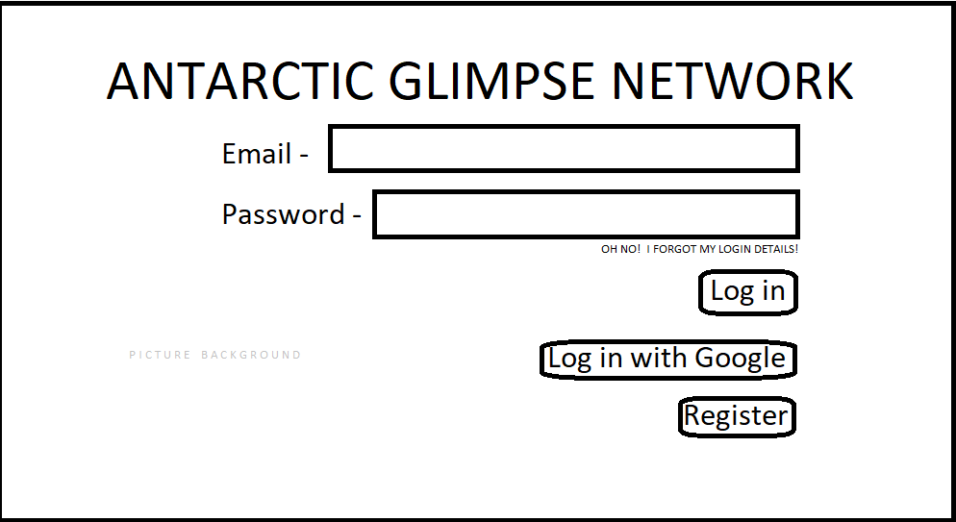
REQ-9: If “Create New Account” button is used, open Google forms window as described in REQ-1.

General User Interface
3.2.2 Description and Priority
This feature allows the user to navigate through the app easily and access different linked functions. Being the frontend, this section must be well designed in terms of layout and usability to give the users a positive experience. Will be designed via Google App Engine, where it will be run directly on user devices.
This feature is important as it provides the linkage and navigation between the many different functions of this application (7/10).
Some possible designs of various screens are included below.
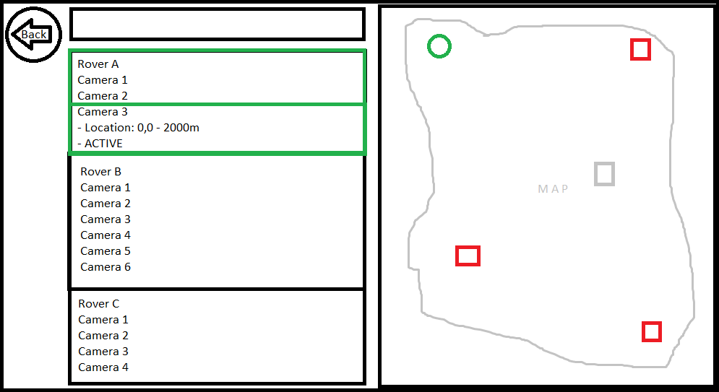
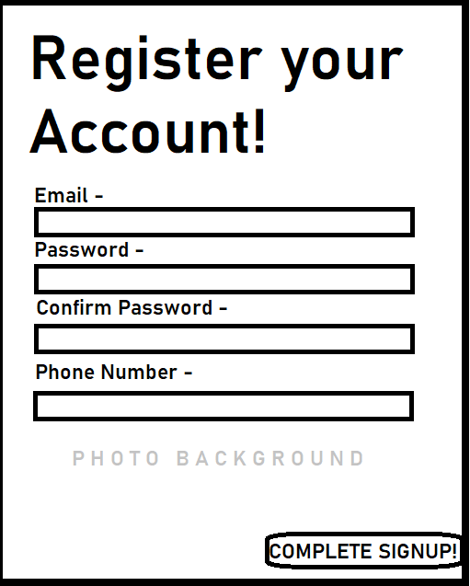
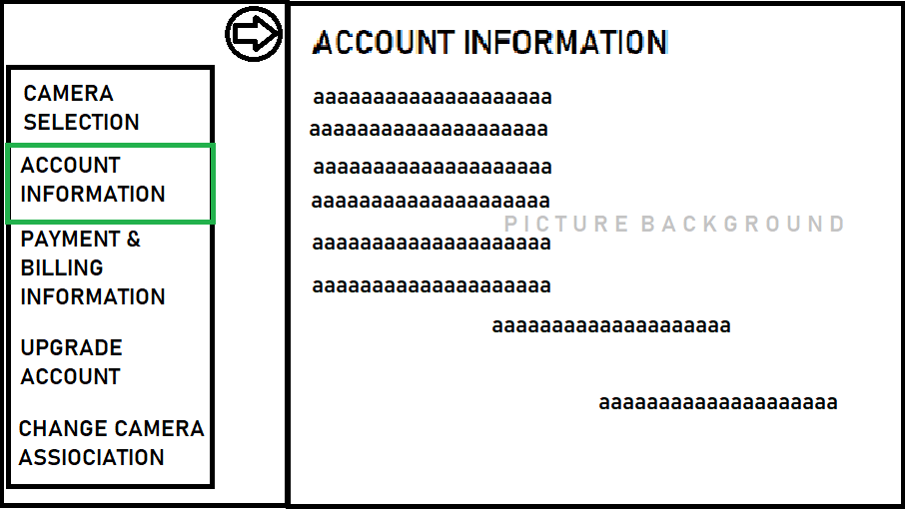
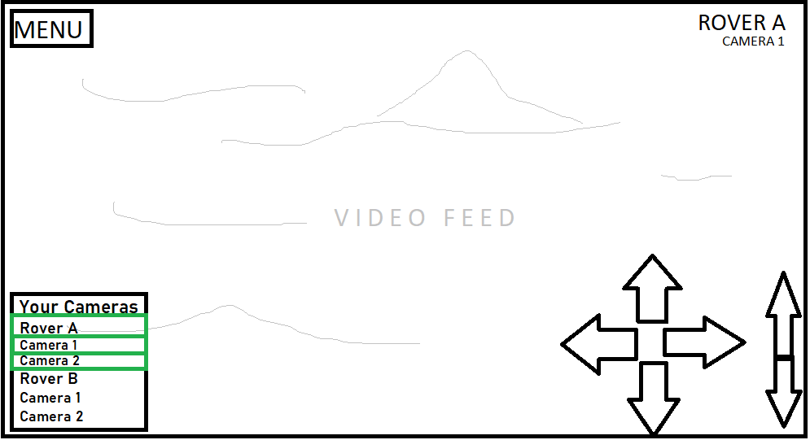

3.2.2 Functional Requirements
REQ-10: Interface should be a size-adaptable window with variable size controls
REQ-11: User account details page should display all details of the user account stored in database except for password and payment/billing information in text format
REQ-12: Payment/billing information from database should be displayed to user in text format. Information should include stored payment method (if it exists in database).
REQ-13: Camera list page should contain a list of cameras that the user can connect to, organized by rover.
REQ-14: Camera list page should contain a map panel that allows the user to select a rover, which highlights the rover cameras in the list.
REQ-15: Map panel should have hide and display functionality.
REQ-16: When camera is selected on camera list page, the list entry should expand and display details more details of the camera.
REQ-17: Expanded list entry should contain a connect button, when pressed, will connect to the camera and begin streaming video via feature 4.4 Camera Feed.
REQ-18: Upon connecting to camera feed, menu should minimise into a small button.
REQ-19: User should be able to reopen menu and connect to another camera freely, disconnecting the current camera in the process.
REQ-20: Camera list should display cameras associated with the user account in a separate category if the user account is of silver or gold premium status.
REQ-21: If the user account is of gold premium status, they should be able to switch their associated cameras via extra menu option in Camera select screen
REQ-22: Switch Associated Cameras panels should have a confirmation message and email acknowledgement for user.
REQ-23: Switch Associated Cameras function and button should be locked for one month after successful use.

Change Password
3.2.1 Description and Priority
This function allows the user to change their password once every 7 days. This is found in the 3.2 User Interface as a menu option. Runs on the frontend side, but receives/transfers data back to the cloud database.
This feature is of low priority (1/10) as it is not strictly necessary, but a useful tool for users.
3.3.2 Functional Requirements
REQ-24: Change password interface accessible via general user interface.
REQ-25: User can change password via internal form window once every 7 days
REQ-26: System will send user an acknowledgement email if password change is successful.

Camera Feed
3.4.1 Description and Priority
This function receives camera video output and displays it on the user’s screen.
Cloud resources will have to be scaled up to manage sending video data to many users as the application becomes more popular.
This feature is of highest priority, as it is the central feature to our application – being able to view live video feed from distant rovers (10/10).
3.4.2 Functional Requirements
REQ-27: User should receive live streaming video from their connected camera
REQ-28: User should be able to freely connect and disconnect to any camera

Camera Movement Control
3.5.1 Description and Priority
This function is an extension of the 4.2 general user interface, which will allow users to control the movement and zoom of the rover cameras.
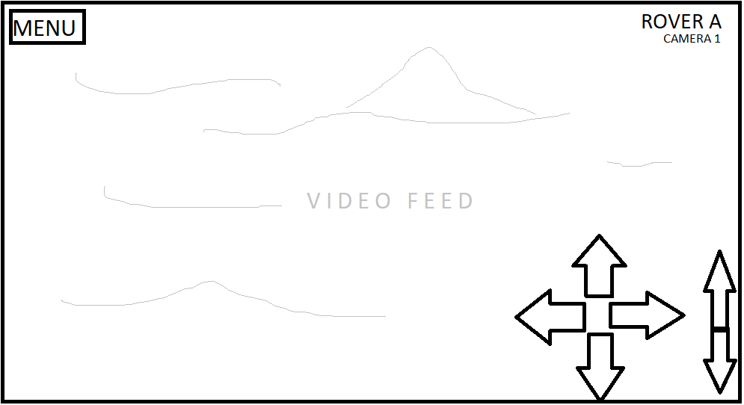
Interface should be simple, allowing for ease of use.
Potential issue if multiple users try to control the same camera. As a result, we must limit camera association, preventing users from being associated with the same cameras.
Scaling
Very high priority, as this is one of the central features of this application and must be completed (9/10).
Basic example of the camera movement UI, with tracking movement on the left and zoom on right.
3.5.2 Functional Requirements
REQ-29: Camera movement interface should appear if user is connected to a camera associated with their account.
REQ-30: Camera movement user input should be transferred to rover camera and respond within 2 seconds 99% of the time.
REQ-38: If camera is associated with two different users, then the user who has connected to it earliest will have control of its movements, while other control input is ignored. Display message to other users if camera is cannot be currently controlled.
REQ-39: Administrators should be able to override camera control from all other users but not other admins. As with REQ-38, admins attempting to control the same camera will allow the earlier connected user to control.
REQ-40: All users should be able to enable/disable camera controls via on screen control if they do not wish to use it, allowing other users to control the camera.

Account Upgrade
3.6.1 Description and Priority
This feature will allow users to upgrade their accounts to silver/gold premium status, which provides control over varying numbers of cameras. To do so, user must make an online payment via this feature, and can save their billing details via Google Pay API.
Silver and Gold premium status lasts for one year. The user may renew their subscription by making another payment or may revert to normal status.
This feature is of high importance, as it is one of the primary goals of the application, providing a source of income for future use (7/10).
3.6.2 Functional Requirements
REQ-31: User can make an online payment via Google Pay API to upgrade user to silver/gold premium status for one year
REQ-32: System should randomly assign 2 rovers and 2 cameras from each to a silver user at status upgrade.
REQ-33: System should randomly assign 3 rovers to a gold user at status upgrade.
REQ-34: System should remove assigned rovers and cameras when a premium user’s status reverts to normal status.
REQ-35: A gold user should be able to reassign three new rovers to itself once every 30 days by picking from a list.

Administrative Privileges
3.7.1 Description and Priority
This function extends feature 3.2, allowing administrative users to modify the details all other non-administrator users in the database.
At present, all accounts designated as administrators possess the full variety of admin abilities. If large numbers of people use this service, so larger numbers of admins are needed, this system can be expanded to set limits on admin powers on a case-by-case basis.
This feature is highly important for general management of large numbers of users, so this system must be completed and be very reliable (8/10).
3.7.2 Functional Requirements
REQ-36: An administrator can manage all aspects of non-administrator accounts.
REQ-37: An administrator can manage all rovers (enable/disable cameras, camera movement, connect/disconnect).

Other Non-functional Requirements

Performance Requirements
Delays: Camera stream delay should not exceed 1.5 seconds in 99% of cases.
Movement input delay should also not exceed 1.5 seconds in 99% of cases.
Because of the general slow pace of the rover and its tasks, we can afford to have slower response times, but not so slow that users get bored. Large response delays are highly frustrating for users.

User data transfer, update and saves must complete successfully and throw acknowledgement message within 1 seconds 99% of the time.
Only a small amount of data per user is transferred when updating details or logging in, speed does not have to be maximised, but kept within a reasonable bound.

As the number of users increase, our cloud-based data transfer must increase in size to maintain the above requirements.

System must be tested prior to release using large numbers of spoof accounts to test resiliency and delays against large number of accounts.

Safety Requirements
All users must be logged in to access any of the applications features.
Users will not be able to access any of the database at any time, while administrators can. Each database access by administrative users must be logged separately.
All database information must be stored in an offline backup, in case data is lost on the cloud storage area for any reason.

Security Requirements
All users must be logged in to access the features of the program.
All users must log in using their account details. If the user uses a pre-existing Google account to log in, the database will store a copy of relevant data (Google account name, password, payment details, status) taken from the Google account, otherwise the database will store a copy of details entered during the registration process.
All stored account data must be kept secure, as it contains valuable details (such as payment methods).
Communication with users should only be done via email, which is more secure and efficient than building in-app communication.

A visual representation of possible issues, requirements and solutions are listed on the next page.

Conclusion
The Antarctica Glimpse Network is a project intended for streaming video data from distant rovers to a multitude of online users. Built using a variety of Google-based services into a relatively simple and robust application, with all backend functionality handled and run by the cloud, and frontend software based on an application file suitable for all the latest browsers and mobile device operating systems. All systems are flexibly designed so that upscaling is a simple task.

As number of users increase, the amount of data sent through cloud and amount of processing power needed to manage actions increases. Cloud software needs to have expansion potential while software itself needs to scale well on a global level
The bandwidth between the rovers, their internet connection and the users may be strained by increasing usage.

Video quality may have to be sacrificed to maintain acceptable time delay between input and output
Database requests presumably will not increase to the point that increased data transfer capacity will be needed.

Database size may need to be increased in future if user numbers increase significantly
Increased user numbers may place a strain on our application, in particular, the transfer of data between the user and through the cloud
Only administrators should be able to access database information manually, the only other access is managed by the backend running on the cloud.

All user data must remain secure and inaccessible by unauthorised parties.
Problems with rover hardware cannot be fixed remotely. If this occurs, admins will have to manually reassign rovers to silver and gold users.
Delays caused by data transfer on the cloud need to be minimised to at most 1.5 second delays independent of travel time. A continuous form of connection should be used to assure a stable, constant data stream. Cloud linkage should be upgraded as necessary to meet delay requirements.

